**Magnetic Effects of Electric Current**

## Magnetic Field and Field Lines

* The space around a magnet in which the force of attraction and repulsion caused by the magnet can be detected is called the **magnetic field**.
* The curved paths along which iron filings arrange themselves due to the force acting on them in the magnetic field of a bar magnet are called **magnetic field lines**.

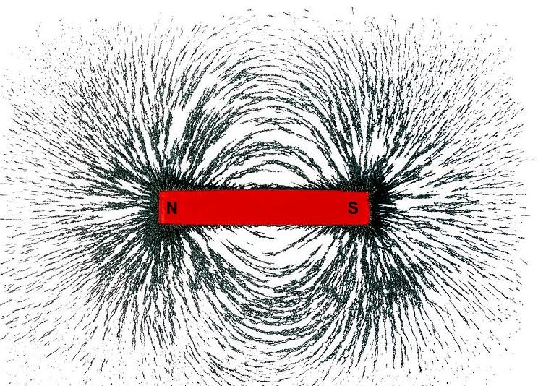

* The direction of the magnetic field at any point is obtained by drawing a tangent to the field line at that point.
* **Properties of Magnetic Field Lines**
  + A magnetic field line is directed from the North Pole to the South Pole outside the magnet.
  + A magnetic field line is a closed and continuous curve.
  + The magnetic field lines are closer where the magnetic field is strong and farther apart where the magnetic field is weak.
  + The magnetic field lines never intersect each other.
  + Parallel and equidistant field lines represent a uniform magnetic field.

## Magnetic Field due to a Straight Current-carrying Conductor

* The magnetic field lines around a straight conductor carrying a current are concentric circles.

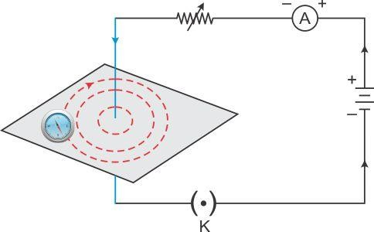

* The direction of a magnetic field is given by the **Right-Hand Thumb Rule.**

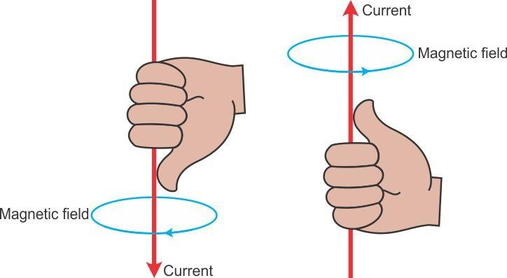

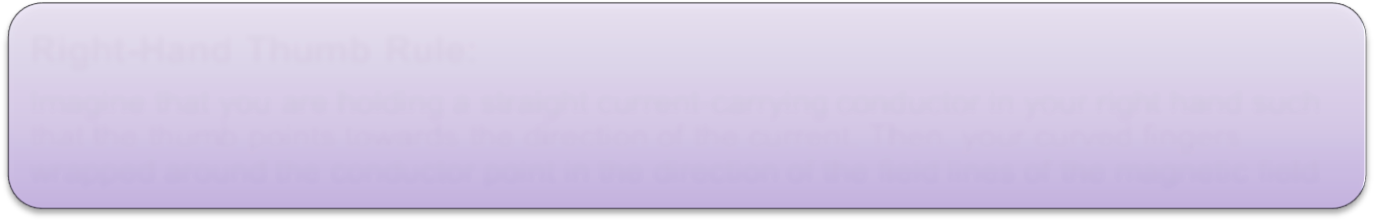

**Right-Hand Thumb Rule:**

Imagine that you are holding a straight current-carrying conductor in your right hand such that the thumb points towards the direction of the current. Then, your curved fingers wrapped around the conductor point in the direction of the field lines of the magnetic field.

* The **magnitude of the magnetic field** due to a straight current-carrying conductor at a given point is
  + Directly proportional to the current flowing through the conductor
  + Inversely proportional to the distance of that point from the conductor

## Magnetic Field due to a Current-carrying Circular Coil

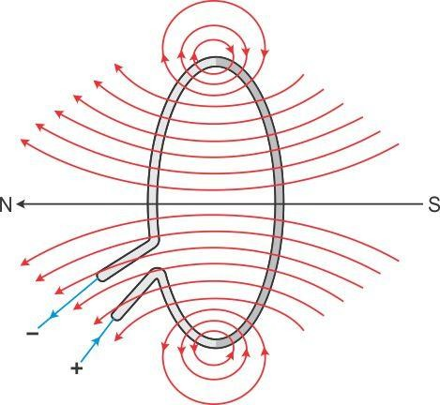

* The magnetic field lines near the coil are nearly circular or concentric.
* The magnetic field at the centre of the coil is maximum and almost uniform.
* Looking at the face of a coil, if the current around it is in the clockwise direction, then it faces the South Pole. If the current around it is in the anticlockwise direction, then it faces the North Pole. This is called the **Clock rule.**
* The **magnitude of a magnetic field** at the centre of the coil is
  + Directly proportional to the current flowing through it
  + Inversely proportional to the radius of the coil
  + Directly proportional to the number of turns of the coil

## Magnetic Field due to a Current-carrying Solenoid

* The pattern of the magnetic field lines around a current-carrying solenoid is similar to that produced by a bar magnet as shown in the figure below.

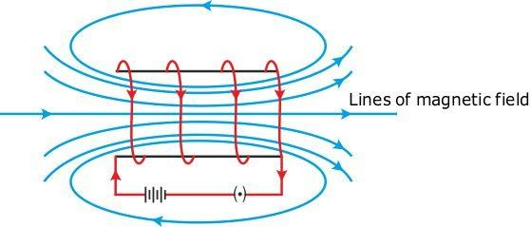

* The magnetic field inside a solenoid is uniform.
* In accordance with the **Clock rule**, the end of the solenoid at which the current flows in the anticlockwise direction behaves as a North Pole, while the end at which the current flows in the clockwise direction behaves as a South Pole.
* The **magnitude of the magnetic field** inside the solenoid is directly proportional to the
  + Current flowing through it
  + Number of turns per unit length of the solenoid

## Force on a Current-carrying Conductor in a Magnetic Field

* A current-carrying conductor when placed in a magnetic field experiences a force.
* The direction of the force gets reversed when the direction of the current is reversed or when the direction of the magnetic field is reversed.
* The force acting on a conductor is found to be maximum when the current and magnetic field are at right angles to each other.
* When the conductor is placed parallel to the magnetic field, no force acts on it.
* **Fleming’s Left-Hand Rule** gives the direction of the magnetic force acting on the conductor.

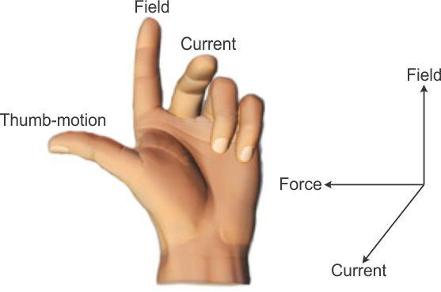



**Fleming’s Left-Hand Rule:**

Stretch the thumb, forefinger and middle finger of the left hand such that they are mutually perpendicular to each other. If the forefinger points in the direction of the field, and the middle finger in the direction of the current, then the thumb gives the direction of motion or the force acting on the conductor.

* The force experienced by a current-carrying conductor in a magnetic field is the underlying principle of an **electric motor** where electric energy is converted into mechanical energy. Such motors are used to run many electrical appliances, including fans, toys etc.

## Electromagnetic Induction

* The phenomenon of generating an electric current in a circuit (coil) by changing the magnetic flux linked with it is called **electromagnetic induction**.
* The change in magnetic flux in a coil may be due to the
  + Relative motion between the coil and the magnet placed near it.
  + Relative motion between the coil and a current-carrying conductor placed near it
  + Change of current in the conductor placed near the coil
* **Fleming’s Right-Hand Rule** is used to find the direction of induced current.

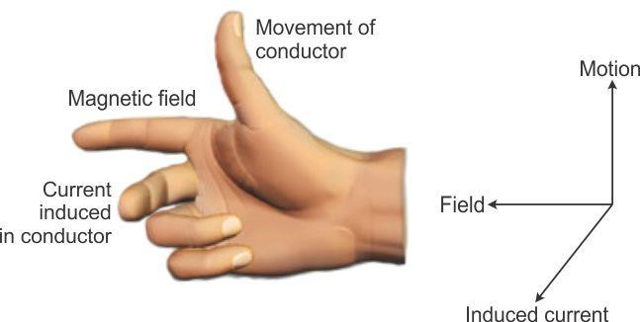

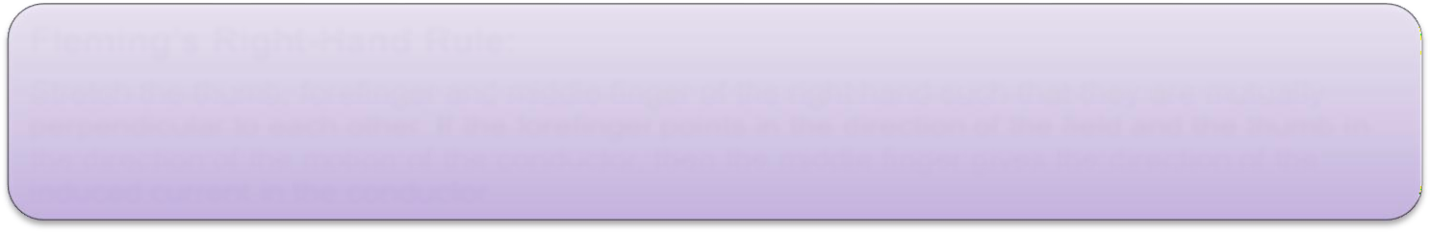

**Fleming’s Right-Hand Rule:**

Stretch the thumb, forefinger and middle finger of the right hand such that they are mutually perpendicular to each other. If the forefinger points in the direction of the field and the thumb in the direction of the motion of the conductor, then the middle finger gives the direction of the induced current in the conductor

## Electric Generator

* The electric generator is based on the principle of **electromagnetic induction** and converts mechanical energy into electrical energy.
* There are two types of generators:
  + AC generator producing a current which periodically changes its direction
  + DC generator producing a current which always flows in the same direction

An **AC generator** can be changed into a **DC generator** by replacing the slip-ring arrangement with the split-ring (commutator) arrangement

## Domestic Electric Circuits

* In our homes, we receive electric power through a main supply called the **mains**. We receive an AC electric power of 220 V with a frequency of 50 Hz.
* One of the wires in the electricity wiring of houses has a red insulation and is called the **live wire**. The other, of black insulation is called the **neutral wire**. The third is the **earth wire** which has green insulation and is connected to a metallic plate deep inside the Earth.

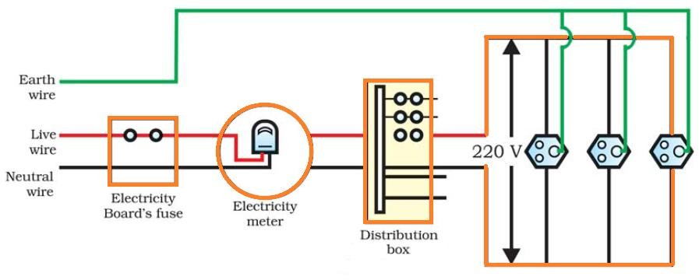

* The earth wire in wiring is used as a safety measure to ensure that any leakage of current in the metallic body does not give the user a severe shock.
* A **fuse** is an important safety device used to protect circuits and appliances from **short-circuiting** (which occurs when a live wire and a neutral wire come in contact) or **overloading** (which occurs when an electric circuit draws more current than the permitted value).